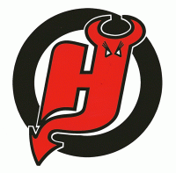 Hamilton Inline Hockey Club is proud to host the

Queen’s birthday junior tournament
4th June – 6th June 2016

The __________________________________ Club wish to enter the following team in the Queen’s Birthday Junior Tournament held from 4th – 6th June 2016.

Grades: u10, u12, u14, Junior women (subject to entry of sufficient teams per grade)

 | Player First Name, Last Name | Player Age | Current NZIHA Club | Player Jersey Number
1
2
3
4
5
6
7
8
9
10
11
12
13
14
Goalie
Goalie
Coach
Manager
Official #3
Official #4

Email or Address to send information and draw: _____________________________
Referees Available:

Name: _________________ Email: ______________________________________ Ph: _________________
Name: _________________ Email: ______________________________________ Ph: _________________

Entry fees include rink entry for players, manager, coach and spectators
- All ages are determined at 1 January 2016 as per NZIHA rules
- All players must be registered with NZIHA in 2016 & NZIHA rules will apply
- 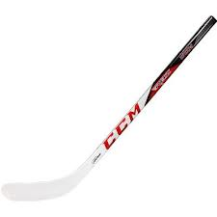Players must play for only one team throughout the tournament (unless dispensation provided prior to commencement of tournament)
- A maximum of 8 teams per grade will be accepted (Acceptances will be the sole prerogative of the organising committee)

Entries Close 17 May 2014

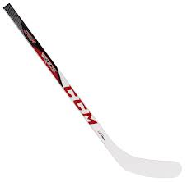Post Entries and Team Entry Fee ($300 per team) to:
Hamilton Inline Hockey Club Queen’s Birthday Tournament
PO Box 274
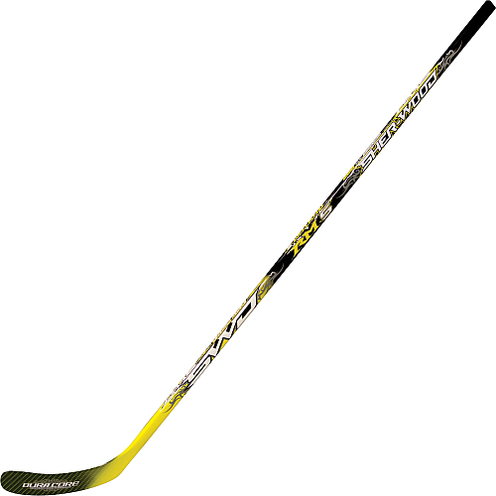Waikato Mail Centre Bank Account Details
Hamilton 3240 020316 0041458 00 BNZ – Hamilton Branch
Email address: tournament@hamiltondevils.co.nz
